**DB LAB TASK # 10**

**MOHAMMAD BASIL ALI KHAN**

**20K-0477**

**Task#01:**

CREATE TABLE person (

personID INT PRIMARY KEY,

FirstName VARCHAR(10),

LastName VARCHAR(10),

Address VARCHAR(50),

City VARCHAR(15),

age INT);

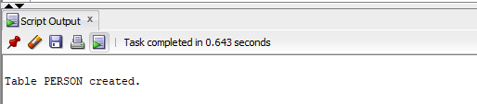

INSERT INTO Person

VALUES(1, 'Basil', 'Khan', 'Johar', 'Karachi',21);

INSERT INTO Person

VALUES(2, 'Ahad', 'Shaikh', 'Malir Cant', 'Karachi', 20);

INSERT INTO Person

VALUES(3, 'Ali', 'Jodat', 'Rizvia', 'Karachi', 22);

INSERT INTO Person

VALUES(4, 'Sohaib', 'Ashraf', 'Askari V', 'Karachi', 21);

INSERT INTO Person

VALUES(5, 'Ali', 'Ahmed', 'Fb Area', 'Multan', 30);

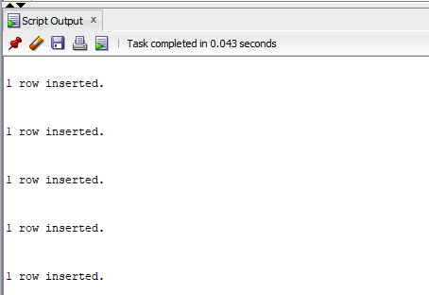

SAVEPOINT savepoint1;

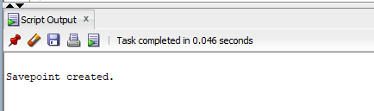

INSERT INTO Person

VALUES(6, 'Ali', 'Uddin', 'Gulshan', 'Karachi', 30);

INSERT INTO Person

VALUES(7, 'Erum', 'Ejaz', 'Gujrat', 'Punjab', 28);

INSERT INTO Person

VALUES(8, 'Jaffer', 'Naqvi', 'Gulshan', 'Karachi', 23);

INSERT INTO Person

VALUES(9, 'Khuawja', 'Ahmed', 'Gulshan', 'Quetta', 19);

INSERT INTO Person

VALUES(10, 'Areeba', 'Rehan', 'Fb Area', 'Karachi', 40);

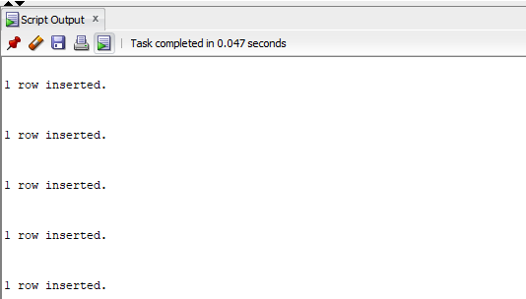

SELECT *

FROM PERSON;

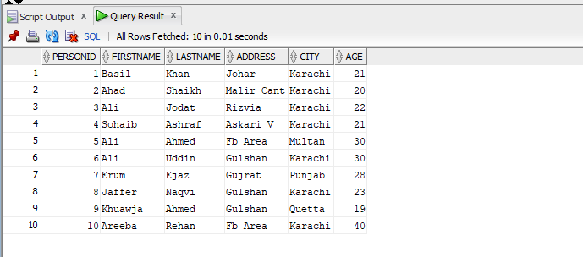

UPDATE Person

SET FirstName='Sidra'

WHERE FirstName='Erum';

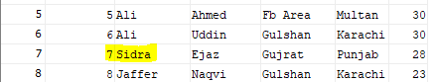

ROLLBACK TO SAVEPOINT savepoint1;

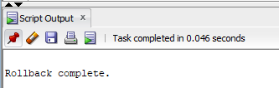

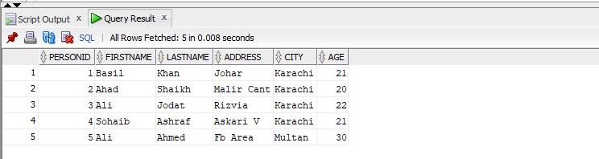

**Task#02:**

UPDATE Person

SET age=30

WHERE personID=8;

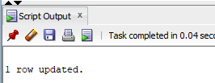

UPDATE Person

SET age=31

WHERE personID=8;

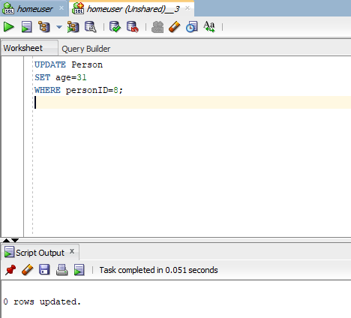

**Reason:**

In order to made changes in new unshared worksheet, we have to go back to previous sheet and commit the transaction in order to update the same record which hasn’t been committed by previous transaction.